While loop
Workshop #1
Flutter Developer Bootcamp

Purpose
This workshop demonstrates the use of a while loop in Dart. This example shows how to initialize a variable, use a while loop to repeat a block of code, and increment a variable within the loop until a certain condition is met.

Problem
In the given workshop demonstrates how to use a while loop to print numbers from 0 to 10 sequentially. It starts with number initialized to 0 and continues printing and incrementing number until it reaches 11, terminating the loop.You need to print numbers from 0 to 15 sequentially.

How to Solve
- Checkout the workshop from Git Repo:
git clone -b <user-branch> <repo-URL>
- Open the root folder inside VS Code
- Open the root folder in terminal
- Run the command dart run filename.dart
- Initializing a variable (number) to start the sequence at 0.
- Using a while loop to repeatedly print and increment number until it reaches 15.
- Printing each number sequentially using the print function.
- Automatically terminating the loop when number exceeds 15, based on the loop condition.
- Go To File: <specific-file--method> à <method-name>, implement your logic.

You will Achieve
When you complete this workshop you will learn the following:

Methods and Functions Used:

- main() Function:
- Entry point of the Dart program where execution begins.
- Takes no arguments (void main() signifies no return value and no parameters).
- print() Function:
- Used to output each number (print(number)) to the console sequentially.
- Demonstrates how to display information during program execution.
- Increment Operator (++):
- number++ is used to increment the value of number by 1 after each iteration of the loop.
- Essential for controlling the loop's progress and ensuring it terminates correctly (number <= 15 condition).

Screenshots

Before implementation (without printing 15 numbers)

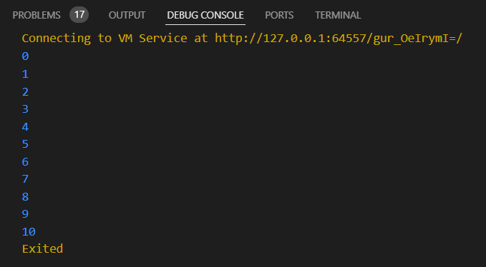

After implementation (with printing 15 numbers)

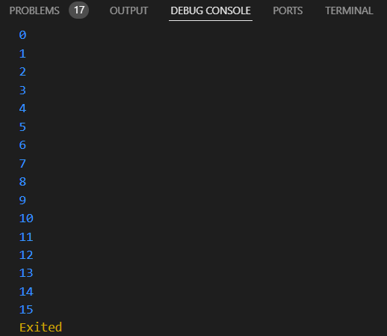

How to submit your workshop
Push your project back to the same git branch using command:
<command name>

Happy Coding!

